Venice, Island of San Giorgio Maggiore
7–9 November 2024

Info Sheet | Artificial Intelligence and public trust
What does it mean for people to trust in Artificial Intelligence? And what can be done in this regard?

Keynote Speaker: Angeliki Kerasidou, Ethox Centre (UK)

Trust is a central issue in the context of data-driven research and innovation, especially when it comes to Artificial Intelligence.
From trust in institutions and companies to trust in technology itself, much attention is now paid to how to ensure, generate and maintain trust. While this is perceived as a key element in the development and introduction of new technologies, how to ensure or promote trust remains elusive. A trust deficit with regard to artificial intelligence seems to persist or even be on the rise. Despite efforts to ensure its trustworthiness, what might be done about it?

What is meant by ‘trust’?

Why is trust so important? Trust is a form of relationship between people, with institutions and with technologies that allows a certain degree of uncertainty to be accepted. Trust is the driving force behind many things, which is why institutions and companies strive for it. In every process, therefore, trust is the essential element for the acceptability and establishment of a given technology.
The efforts by companies developing AI systems to produce documentation that effectively demonstrates their trustworthiness right from the product design stages are clear. The challenge is to incorporate ethical principles and regulations directly into the technology design process, with the aim of transmitting trustworthiness directly to the final product. However, despite the efforts of various companies, it does not seem that greater reliability is directly matched by greater trust on the part of the end consumer.

The aim: looking at public trust

To build a true relationship, companies and institutions should look to another type of trust: public trust. This is the trust that the public has in those companies that operate to serve the common good. Since healthcare is regarded as a public commodity, there is a particular distrust on the part of the consumer towards companies that develop technological systems linked to this sphere.

Trust in AI is falling

According to the latest publication of the Edelman Trust Barometer 2024, trust in Artificial Intelligence seems to be declining across the board at a faster rate in developed countries, despite the fact that they have greater access to information about such tools.
This suggests that where artificial intelligence is most developed, there is less trust in it. 42% per cent of respondents do not view the use of artificial intelligence in interaction with patients positively, while 32% are doubtful about its implementation in the development of new drugs. Criticism also remains on the medical diagnosis front where 31% of respondents reject this type of application altogether.

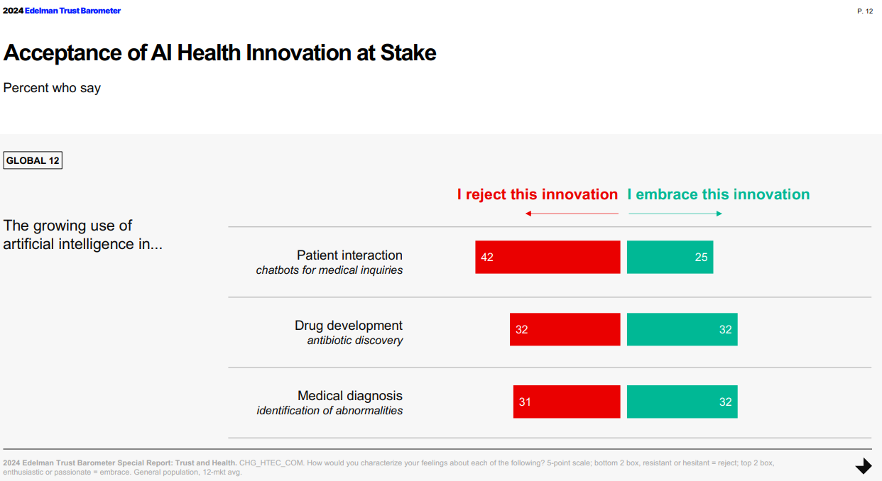

A study conducted by Angeiliki Kerasidou and her team monitored the perceptions and views of healthcare professionals regarding the use of AI tools on their patients. What emerges is that doctors and healthcare professionals are looking for tools that are reliable and of adequate effectiveness for their patients. In other words, it is not enough to be reassured by companies that these technologies work, but they need to know how and why they work, with what levels of accuracy they work, and perhaps participate in the validation process themselves.
As a result, patients demand the validation of AI technologies directly from healthcare providers. According to citizens, only those tools serving the public good that are validated by those who have the suitable means to evaluate them should be released.

The AI monopolies

Advances related to the development of AI technologies mainly concern private investments. Is there a geopolitics of trust? Is there more trust in American or in Chinese Artificial Intelligence?
It should be emphasised that trust is mainly based on the experiences of individuals that lead them to develop a reasonable belief. For some, therefore, certain countries or certain institutions and companies primarily represent the experience they have had with them in the first or second person. One must then consider what are defined as technological monopolies and ask whether the fact that people use certain products is necessarily an indication of trust.

Angeliki Kerasidou

An expert in ethics, she is an associate professor at the Ethox Centre and a researcher at the Wellcome Centre For Ethics and Humanities at the University of Oxford. Her research work investigates the ethical aspects of data-driven technologies in healthcare and health research.
She is co-chair of the ethics modules for the CDT in Health Data Sciences in the Department of ICT and for the MSc in Global Health Science and Epidemiology at Oxford Population Health. She is course leader for Research Ethics and Research Integrity and for Ethics and Law of Abortion and Artificial Reproductive Technologies for the Division of Medical Sciences.

Angeliki Kerasidou will be a keynote speaker at the Global Health in the Age of AI. Charting a Course for Ethical Implementation and Societal Benefit Symposium on 8 November 2024, at 9.30 am.

To follow the live streaming of the event: access the Fondazione Giorgio Cini YouTube channel

